ANSWERS to Chromatography Exam Questions

1. A student investigates the colours contained in inks from felt-tip pens. He uses chromatography and sets up his experiment as shown:
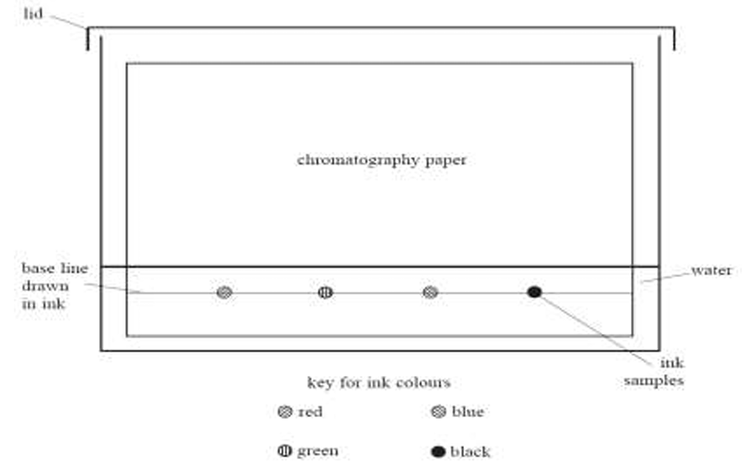

(a) Identify two mistakes in the way he sets up the experiment. For each mistake, state what problem it would cause.

1st mistake = Water level is higher than the ink samples.

Problem = Problem = Ink would dissolve down into the water rather be separated upwards on
the filter paper.

2nd mistake = The base line is drawn in pen.

Problem = The ink in the base line would also be separated, which would interfere with the
results of the other inks.

(b) Another student repeats the experiment, but does not make any mistakes. She uses inks from four different felt tip pens. The diagram shows her results.
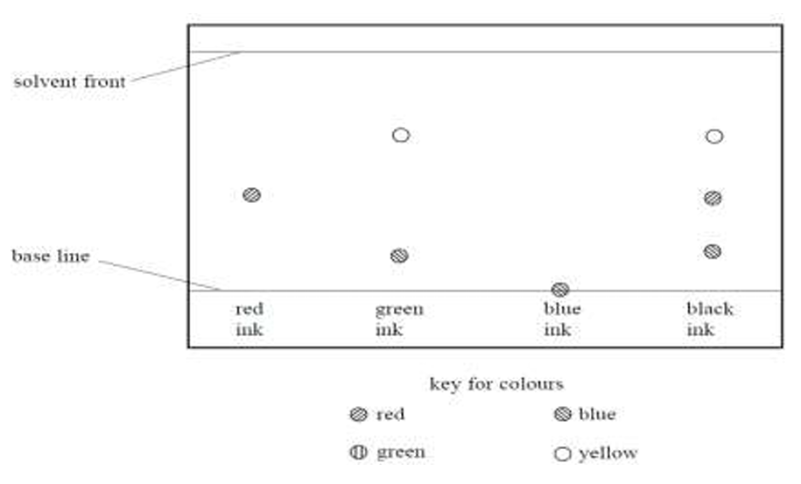
(c) (i) How many different colours does the black ink contain? 3

(ii) Which of the inks tested could be mixed together to make the black ink? Green and Red

(iii) Which of the inks tested is insoluble in water? Explain your answer. Blue ink as it doesn't
move, so this means it can’t have dissolved in the water.

2. A student investigates the pigments found in some vegetables and fruit. She obtains some coloured vegetable and fruit extracts from carrots, tomatoes and sweet potatoes. She places a spot of each extract on chromatography paper, along with spots of the three pigments beta-carotene, chlorophyll and lycopene. Her teacher provides a solvent containing volatile, flammable, organic compounds for the experiment. The diagram shows the apparatus at the start of the experiment:

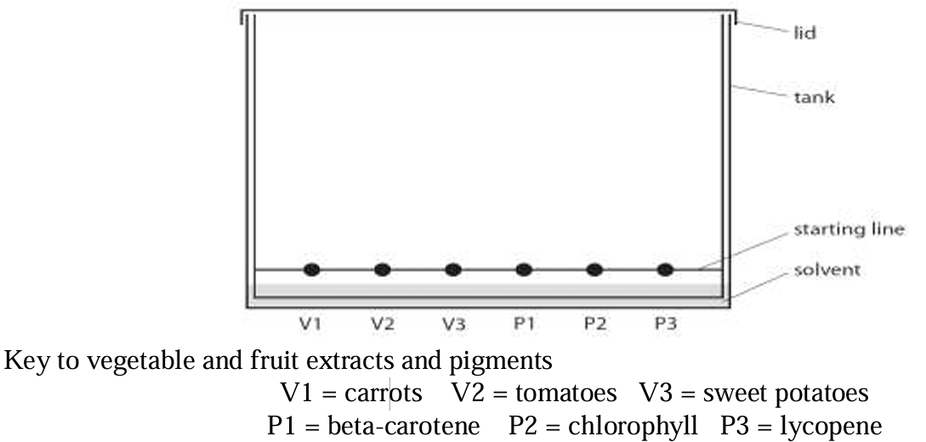

(a) Explain why it is important for the solvent level to be below the spots. Otherwise the spots will dissolve downwards into the solvent rather than be separated by the solvents upwards.

(b) State two potential problems that are prevented by fitting the tank with a lid. Any two from:
- The solvent is volatile (which means it is smelly and evaporates quickly). The lid prevents this.
- The solvent is flammable (sets fire easily). The lid makes the process safer.
- The lid could also prevent any material entering the test and interfering with the results.

The diagram shows the chromatogram at the end of the experiment.

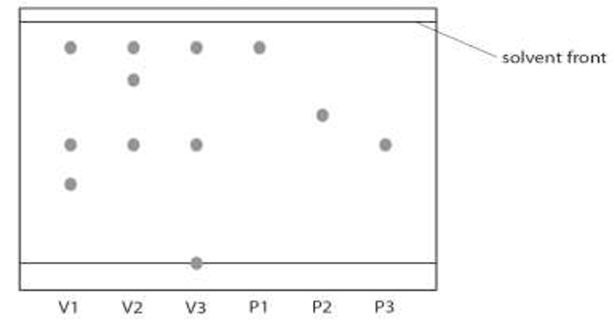

(c) Put a tick next to three statements that are supported by the chromatogram.
✓ | Chlorophyll is not present in carrots, sweet potatoes or tomatoes
 | Beta-carotene is present in carrots but not present in tomatoes.
✓ | Both beta-carotene and lycopene are present in sweet potatoes.
 | Lycopene is present in tomatoes but not present in carrots.
✓ | Both carrots and tomatoes contain a pigment other than beta-carotene, chlorophyll and lycopene.

(d) Suggest a reason why there is a spot on the starting line in the chromatogram for sweet potatoes.

This colour or pigment does not dissolve in this solvent or liquid.

